RPT COMPOSITION OF NON-TENURE TRACK DOSSIERS
There are three separate RPT templates, for research faculty, teaching faculty, and librarians. Your individual case in RPT will only include the sections that you need to complete based on your professional title. All template sections are described below, but please remember that no RPT case will include all these sections. Follow the naming conventions as indicated:

A. Candidate Information
Required: S&T NTT Candidate Information Form
B. Candidate’s CV
Required: Upload your CV. FirstInitialLastName_CV

C. Research (applies to research-track faculty)
Required Materials
- Research Statement -- Self-Assessment. FirstInitialLastName_ResearchStatement
- OSP Grants and Expenditures. FirstInitialLastName_OSP
- Form A: Scholarly Work Published since date of initial employment at S&T or since last promotion. FirstInitialLastName_Publications
- List of Internal Grants (fillable form in RPT)
Optional Materials
- Form B: Graduate Faculty Related Activities Summary. FirstInitialLastName_GradFac
D. Teaching (applies to teaching-track faculty)
Required Materials
- Teaching Statement – Self Assessment. FirstInitialLastName_TeachingStatement
- Form C: Summary of SET. FirstInitialLastName_SET
- List of Internal Grants (fillable form in RPT)
Optional Materials
- OSP Grants and Expenditures. FirstInitialLastName_OSP
- Form A: Scholarly Work Published since date of initial employment at S&T or since last promotion. FirstInitialLastName_Publications

E. Extension
Required: Form D: Extension Statement and Activities. FirstInitialLastName_Ext

F. Service

Required: Service Statement – Self Assessment. FirstInitialLastName_ServiceStatement

G. Professional Development Activities

Optional Materials
- Professional Development Activities List (up to 1 file) FirstInitialLastName_ProfDev

H. Supplementary Information
Required for some; see below for further instructions: Letters of Support. FirstInitialLastName_LettersofSupport
Optional Materials: Publications: links to up to five publications (fillable form in RPT).
I. Verification of Accuracy
- Open RPT to attest that all submitted information is accurate.
*******************************
Instructions: Please refer to the guidance below when completing each section of your dossier in RPT. Reach out to Faculty Affairs at with any questions.

A. Candidate Information
Answer each question carefully. Evaluators will refer to these answers when reviewing your application.
B. Candidate’s Curriculum Vitae (CV)
The CV should represent the candidate's experience and contributions as accurately and completely as possible. Incomplete or potentially misleading information — even by omission — can weaken an otherwise strong case, as evaluators will consider both what is included and what is left out.
While no single format is required, the CV should include most of the following sections. Omit any that are not relevant to your position.
- Name and Current Academic Address
- Academic Background
List all degrees earned, including the department, institution, and dates of attendance. Include the title(s) of any thesis or dissertation and the name(s) of the advisor(s).
- Work Experience
Provide a complete employment history, including position titles, employer or industry, and dates of employment.
- Scholarly Contributions
Organization: Group contributions into clearly labeled categories: books, refereed journal articles, refereed conference papers, other publications, abstracted talks, invited lectures, and other scholarly contributions. List refereed conference papers separately from refereed archival (journal) papers.
Co-authored work: For all co-authored works, indicate the candidate's degree and nature of contribution.
Required citation information: All publications, refereed or otherwise, should include: author(s), title, journal name, volume, page numbers, and publication date. For book chapters, also include the editor's name, publisher, and publisher's location.
Each entry should contain enough information for the work to be easily located.
Presentations and oral contributions: Include the date, location, and sponsoring organization, with enough detail for an evaluator to verify the contribution.
Creative works: Exhibits, performances, or showings should be described in sufficient detail for evaluators to assess the scholarly or creative achievement.
- Research Grants and Contracts
List all grants and contracts received. For each, include the project title, funding agency, total dollar value, period of expenditure, and the candidate's speciﬁc role. As with co-authored publications, clearly describe the division of labor among investigators.
- Teaching Experience
List teaching positions by institution, including dates of service, general subject areas, and the academic level of courses taught. Detailed descriptions should be omitted from the CV and submitted as supplementary material if needed.
- Department and University Service

List committee memberships and special responsibilities, including dates of service.
- Professional Service and Society Memberships
List memberships in professional organizations, including any offices held and dates of service.
- Additional Items
Other relevant information may be included at the candidate's discretion. Any addition should be evaluated for whether it strengthens the overall picture of the faculty member’s performance. Candidates are strongly encouraged to review their CV with their department chair and other mentors before submission.

C. Research (for faculty with a research assignment)
Research Statement – Self Assessment. This section allows candidates to provide a substantive, critical self-assessment of their scholarly and research accomplishments. Rather than cataloguing all contributions exhaustively, candidates should focus on a representative selection of their most signiﬁcant work — discussing its signiﬁcance, coherence, impact, and trajectory.
The assessment should also address the following:
- Research philosophy. Candidates are encouraged to articulate the intellectual framework guiding their research.
- Innovative contributions. Candidates should identify what is original or distinctive about their work.
- Broader research context. Candidates should situate their work within its broader research context. When relevant, candidates may discuss how shifts in funding priorities or changes in external support have shaped their research and demonstrate their initiative, adaptability, and sustained commitment to scholarly productivity.
- Future directions. Candidates should outline their plans for continued scholarly activity.
The ability to evaluate one's own work thoughtfully and accurately — recognizing its strengths, limitations, and place within the ﬁeld — is itself a mark of professional judgment and intellectual leadership.
Along with the Research Statement—Self Assessment, research-active faculty must complete and upload Form A, which lists published works. Note: Actual publications are not included in the dossier, but you may include hyperlinks to up to ﬁve publications in the Supplemental Information section (Section H; see instructions below). The research section of the dossier also includes a completed sponsored research activities report since last promotion and a report from the Vice Chancellor for Research and Innovation regarding research expenditures. These documents are generated by the Office of Sponsored Programs and are sent to the candidate from the Office of Faculty Affairs to be reviewed before being uploaded into RPT.
The candidate may choose to add information about grants submitted but not received onto the OSP Grants and Expenditures Report. If choosing this option, please include the title, name of the PI and CO-PI, percent of effort, name of the funding agency, and total direct cost. The candidate should also complete and upload the optional Form B (Graduate Faculty Related Activities Summary), if there are graduate activities to report. Finally, the candidate must enter information about any internal grants received; a ﬁllable form opens up in RPT. If no internal grants were received, select “no” for the ﬁrst question.

RPT Actions for Section C:
Upload the following:
- Research Statement -- Self-Assessment (Required)
- OSP Grants and Expenditures (Required)
- Form A: Scholarly Work Published (Required)
- List of Internal Grants (ﬁllable form in RPT) (Required)

- Form B: Graduate Faculty Related Activities Summary (Optional)

D. Teaching (for faculty with a teaching assignment)
Teaching Statement – Self Assessment: This section allows candidates to present a rich, multidimensional picture of their teaching effectiveness. Student evaluation scores (SETs) are one data point among many, and candidates are encouraged to draw on a wide range of evidence to illustrate the quality and impact of their teaching.
The self-assessment should include a discussion of teaching philosophy: the values, principles, and approaches that guide the candidate’s teaching. This document might also include reﬂections on teaching techniques, methods, and goals; a discussion of how one’s teaching has evolved over time; and/or descriptions of challenges encountered and adjustments made in response. Candidates should discuss their SET scores in context rather than reporting them in isolation. This includes interpreting trends over time, explaining differences across courses or course levels, and describing how student feedback has informed adjustments to their teaching. Candidates should highlight any new courses designed or existing courses that have been substantially revised. Candidates should include evidence of teaching effectiveness, which might include student feedback, evidence of student success, curricular and pedagogical contributions (i.e., development of new instructional materials, adoption of innovative or evidence-based teaching methods, integration of research or real-world problems into coursework, publications or presentations in education journals or pedagogy conferences, grants received to support teaching innovation or curriculum development); evidence of student engagement and mentorship, and/or recognition and external validation (i.e., teaching awards/nominations, invitations to share teaching expertise at workshops or conferences, adoptions of course materials or approaches by others). You may discuss your teaching-related accomplishments since your initial appointment at S&T or since your last promotion.
Form C: Summary of SET: Include information for each course taught or team-taught since your initial S&T appointment or since your last promotion (for a maximum of ﬁve years).

RPT Actions for Section D:

Upload the following:
- Teaching Statement – Self Assessment (required)
- Form C: Summary of SET (required)
- List of Internal Grants (ﬁllable form in RPT) (required; if none, indicate in the form)
- OSP Grants and Expenditures (optional; if you have received external grants, reach out to facultyaffairs@mst.edu to request this report)
- Form A: Scholarly Work Published since date of initial employment at S&T or since last promotion (optional)

E. Extension

If your workload includes activities associated with UM System Extension, use this section to describe those activities and your accomplishments/contributions to Extension and Continuing Education. If you have no Extension activities, fill out Form D by clicking the box next to “I have no extension activities to report.”

RPT Actions for Section E:

Upload the following:
- Form D: Extension Statement and Activities (required)

F. Service

Service Statement – Self Assessment: This section should include a self-assessment of the candidate's service contributions at the department, college, university, system, and professional/disciplinary levels. The document should offer a reﬂective account of the level and quality of the candidate’s engagement in these service activities. Candidates should go beyond listing committee memberships and other activities to describe what they contributed. Where a candidate played a signiﬁcant role — drafting a report, leading a working group, designing a survey, or otherwise shaping an outcome — that contribution should be documented and discussed in concrete terms.
RPT Actions for Section F:

Upload the following:
- Service Statement - Self Assessment (required)

G. Professional Development Activities

Share information about activities you’ve engaged in to enhance your professional development, including workshops, seminars, conferences, and other related opportunities hosted on- or off-campus.

RPT Actions for Section G:

Upload the following:
- Professional Development Activities (optional)
H. Supplementary Information

This section asks for links to up to ﬁve publications (optional) as well as a single document combining your letters of support. For non-tenure track (NTT) promotions, external letters are required when moving from associate to full professor. Letters are not always required for promotion from assistant to associate professor, so candidates should carefully read their department’s NTT promotion policy. Letters of support from former advisors, collaborators, and colleagues may be included in this section. A page should be included indicating the conditions under which letters of support were received, i.e., whether they were solicited by an independent third party, solicited by the candidate, or received unsolicited. All letters of support must indicate the letter writer’s title and the relationship of the letter writer to the candidate, i.e., colleague, collaborator, administrator, student, former student, etc.
RPT Actions for Section H:
Upload the following:
- Links to up to ﬁve publications (optional; this ﬁllable form opens in RPT)
- One document including all letters of support

I. Verification of Accuracy

- Open RPT to attest that all submitted information is accurate.

Form A
Scholarly Work Published Since First Employment at S&T or since last promotion for a maximum of ﬁve years
If there are publications with multiple authors, publication references should appear with authors listed in the order that they appear in the journal. Additional information about authors and contributors may also be indicated (e.g., undergraduate student contributor, graduate student contributor, etc.). At the end of the citations for each publication with multiple authors, describe the candidate’s contribution to the work in terms other than percent of effort.

Please complete each section listing the appropriate publications that have been accepted or published while the candidate (underline candidate’s name in each publication) has been at Missouri S&T or since last promotion for a maximum of five years. Use the following superscripts:
1 - Corresponding Author
2 - Student
3 - Former Advisor is Author
4 - Other Faculty/Post Docs
Status: Add (in press) at the end of the full citation.

Note: Do not include actual publications in this section; up to five publications can be included in a Supplemental Dossier saved as a single pdf file.
Refereed Journal Articles:
1. Lennon2, J.; McCartney1, P.; Starr3, R.; and Harrison4, G. A Hard Day’s Night. Apple Recording Company, 1964.
2. McCartney1, P and Starr3, R. And now we are in our seventies. Unknown Recording Company, 2018 (in press).
Add numbers as needed Books
1.
2.
Add numbers as needed
Conference Proceedings (Only list those presentations not accompanied by a conference publication):
1.
2.
3
Add numbers as needed Book Chapters:
1.
2.
Add numbers as needed Other Creative Activities
1.
2.

(Example Document)-This report will be sent to you by Faculty Affairs
Page 1 of 2
OSP Grants and Expenditures
SPONSORED RESEARCH ACTIVITIES
LATEST FIVE YEAR SUMMARY

NAME:

College Committee:
DEPARTMENT:
GRANTS

FISCAL YEAR*

2015 | 2016 | 2017 | 2018 |  | 2019
Total Awarded ($) | $0 | $0 | $0
Shared Credit ($) | $0 | $0 | $0
Total Expended ($) | $0 | $0 | $0
Shared Credit ($) | $0 | $0 | $0

* Note: Fiscal year is defined as July 1 through June 30. For example, FY 2019 is from July 1, 2018
through June 30, 2019. Please note in the spaces below information for any grants obtained in
FY 2020 (awarded, shared credit and expended since July 1, 2019).

Awarded: ($): Shared Credit ($): Expended ($):

PROPOSALS

Fiscal Year 2020 Proposals**

Pending: Number: Dollar Amount: Shared Credit ($):

Accepted: Number: Dollar Amount: Shared Credit ($):

** If appropriate, on an attached sheet, report the number, dollar amount and shared credit for any pending or accepted proposals from earlier fiscal years that have not yet been awarded.

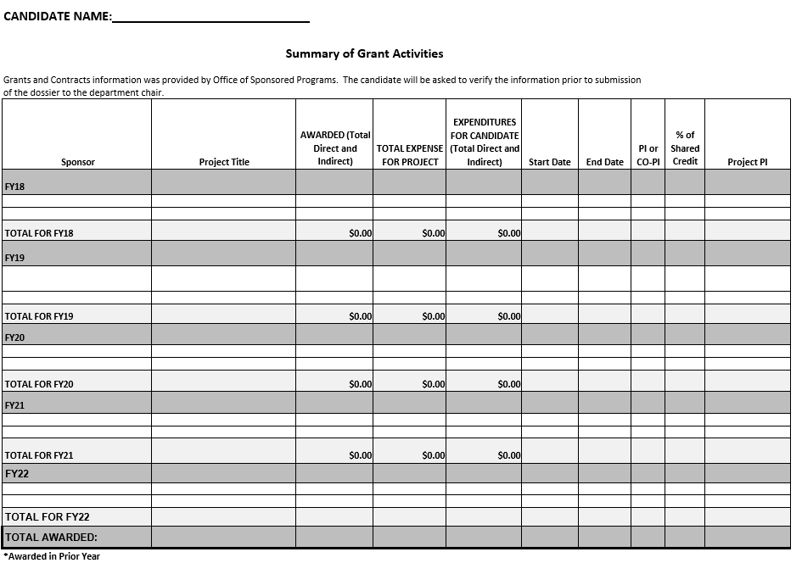
Page 2 of 2
Form B

Graduate Faculty Related Activities Summary

NAME:
COLLEGE:_________________________________________________________________________________
DEPARTMENT: INITIAL MEMBERSHIP DATES:

General Faculty:
Graduate Faculty:
ACADEMIC YEAR*
Include information since your date of initial employment at S&T or since last promotion for a maximum of five years

Year | # M.S. students advised | # Ph.D. students advised | # M.S. degrees completed -advisor | # Ph.D. degrees completed -advisor | 5000 level* courses taught | SCH | 6000 level* course taught | SCH

* Do not list 5000, 5001, 5099, 6000, 6001 or 6099.

Form C
Summary of SET Table
From your first semester as an employee at S&T or since last promotion for a maximum of five years

Semester | Course Title | Credit Hours | Number of Students/  Number Evaluating | Overall SET Score

EXTENSION ACTIVITIES
The completed Form D is a listing of the last five years of extension and public service activities. It should include teaching short courses, research done through Continuing Education, the details of technology transfer efforts, and similar Continuing Education activities. The Department Chair or Associate Provost for Faculty Affairs can provide guidance regarding appropriate information to include in this section.
If no extension activities are reported, the candidate should check the appropriate box, sign and date the form and include it in the dossier.

Form D
FACULTY EXTENSION AND CONTINUING EDUCATION ACTIVITIES FIVE YEAR SUMMARY

I have no extension activities to report.

Faculty Member's Signature Date

Credit Courses: Year Course Name %FTE

Short Courses
and Conferences: Year Name of Short Course or Conference %FTE

Problem Solving: Year Nature of Problem Hours Spent

Grants: Year Amount Awarded Grantor

Publications:

